CHAPTER 1: INTRODUCTION
  - Background of the Study
In the modern era of smart cities, waste management remains a critical pillar of public health. Traditional waste bins require physical contact for operation and offer no feedback on their fill status, often leading to unhygienic conditions. The smart dustbin project addresses these issues by automating lid movement and measuring how full the dustbin is so as to alert the proper authorities of the dustbin status to know when to empty it. It also offers a more hygienic solution which can reduce the spread of pathogens through dustbins.
  - Problem Statement
Manual waste disposal systems contribute to the spread of pathogens through surface contact. Additionally, the lack of automated monitoring leads to inefficient waste collection cycles, where bins either overflow or are emptied while nearly empty, wasting municipal resources.
1.3 Objectives
General Objective: To design and implement a functional, sensor-driven smart robotic dustbin that automates waste disposal and improves hygiene.
Specific Objectives:
To design and simulate the control system using Proteus and Tinkercad.
To develop analog signal conditioning circuits for the ultrasonic sensor.
To program an ATmega328P microcontroller for real-time response.
To produce a professional PCB layout for the internal electronics.
To assemble a durable physical prototype.
To publish the project architecture on GitHub for open-source review.
1.4 Research Questions
How accurately can an ultrasonic sensor detect approach vs. ambient movement?
What is the power efficiency of a servo-driven lid compared to traditional mechanical systems?
By how much would this project actually reduce pathogen transfer?
1.5 Significance of the study
This study would be able to successfully reduce disease transmission in cities with poor waste management systems and also in cities with good waste management as most pathogens transferred through dustbins are transferred by contact with the dustbin but with our project we have automated this process making it a non-contact process leading to lesser disease transmission. Also, this project will help manage municipal resources as it will help manage waste collection cycles so that dustbins wouldn’t be emptied when nearly empty leading to waste of resources or being emptied when the dustbin is overflown with waste due to lack of feedback on the dustbin status thus promoting spread of pathogens.
1.6 Scopes and Limitation
This project focuses on the design and prototyping of a smart dustbin using an ultrasonic sensor to measure distance, a servo motor to control the lid, and two LEDs to give feedback. The current prototype is designed for both indoors and outdoors use though it may not be as efficient in the outdoor use due to factors such as: lack of waterproof casing, small detection range, easy to get damaged, and a lack of a constant power source to keep it running for a long period.
CHAPTER 2: LITERATURE REVIEW
2.1 Introduction
Cities are growing fast, way faster than anyone expected. As more people pack into urban areas, the amount of trash piling up just keeps climbing. The old ways of dealing with waste? They're just not cutting it anymore. Manual collection, fixed schedules, open bins, all that leads to filthy streets, pests, and, honestly, some nasty health risks. It’s even worse in developing countries, where resources are tight and people aren’t always aware of proper hygiene.
Lately, a lot of attention has turned toward “Smart Cities” basically, using robotics and the Internet of Things (IoT) to make city services smarter and more efficient. Automating waste management means fewer people have to touch or handle trash, which keeps everyone safer and makes collection routes way more efficient. At the heart of this shift is the “Smart Dustbin.” These aren’t your average trash cans. They’re loaded with sensors and motors, so they can open their lids automatically, check how full they are, and even sort out different types of waste.
This chapter digs into the theory and the real-world tech behind smart waste systems. It takes a closer look at current robotic solutions, breaks down the hardware and software that make them work ( Arduino boards, or simulation tools like Proteus and Tinkercad), and explains why certain technologies were picked over others.
2.2 Review of Existing Similar Robot
If you look back over the past ten years, smart bins have become a hot topic. There’s a ton of research out there, from simple touch-free lids to full-blown robots that roll around on their own. Here’s a closer look at some types of systems people have built and studied.
1.Early Automated Bins:
It all started with the pedal bin. Back in the 1920s, Lillian Moller Gilbreth came up with this hands-free trash can so you didn’t have to touch the lid. Fast forward to today, and “smart dustbins” usually mean bins packed with ultrasonic sensors to open the lid or check fullness, and IoT connections to send alerts. Nobody invented this overnight it’s the result of projects and research popping up all over, often using Arduino boards.
2. IoT-Enabled Waste Monitoring Systems
Folin and colleagues (2016) took things a step further with the “connected bin.” They hooked up a GSM module and another ultrasonic sensor, so when the bin hits 90% full, it automatically sends a text to the city’s waste department. No more trucks driving around emptying half-full bins, only the ones that really need it. That saves a ton of fuel and helps cut down on pollution.
3. Autonomous Garbage Collector Robots (AGCR)
Why stop at stationary bins? Autonomous garbage collector robots have been developed by various researchers and companies, with notable examples including the Dustcart robot by Scuole Superiore Sant-Anna, Robodumpster by Rama Prabha, and the HARR-E™ robot by Pratt Miller. These robots, often designed for urban cleaning or specialized waste removal, use sensors and AI to navigate and collect trash.

4. AI-Based Waste Segregation Bins
Sorting trash is a huge headache, but SmartBin Tech in a joint development with the University of Technology Sydney (UTS) and the Commonwealth Scientific and Industrial Research Organisation (CSIRO), has developed AI and infrared spectroscopy technologies for detecting, classifying, and sorting recyclables.
5. Voice-Controlled Service Robots
The company Simplehuman created a commercial smart bin, model ST2015, that responds to voice commands like "open can" to automatically open its lid for a hands-free experience.
6. Solar-Powered Compactor Bins
Al-Masri (2018) took a close look at solar-powered compactor bins, for example, one of those “Bigbelly” bins you sometimes spot in parks. These bins run on solar energy and use tough DC motors to crush the trash inside, so they fit up to eight times more waste than a regular bin. Because they don’t need any external power, they work great in public outdoor spaces where you can’t just plug something in.
7. Line-Following Waste Carriers
Line Follower Waste Carriers was created by Irham Aldiyanto in a project published on Hackster.io in December 2021. This project was designed to automate the process of collecting full trash cans on a campus.

8. Smart Bin with Weight Sensors
The integration of weight sensors (often load cells) and other sensors (like ultrasonic fill-level sensors) with communication technology (GSM or Wi-Fi) to create a "smart bin" has been the subject of multiple research and development efforts. In 2020, a paper titled "Development of Smart Waste Bin with Integrated Volume and Weight Sensor" was published, listing authors such as Tom Maus, Nico Zengeler, and others.
9. GIS-Integrated Waste Management
It was developed through various research and applications by multiple researchers in the 2000s, such as A.C. Caputo & P.M. Pelagagge (2000s) WIT Press and Nikolaos V. Karadimas (2005) ResearchGate, to optimize collection routes and landfill site selection using Geographic Information Systems (GIS).
2.3 Analog Circuit Techniques in Robotics
Even though a smart dustbin’s logic is digital, it still relies heavily on analog circuits to actually interact with the real world. The way sensors talk to the microcontroller, analog signal processing is key for keeping things reliable.
Sensor Signal Conditioning
The ultrasonic sensor (HC-SR04) in this project uses analog sound waves, shooting out a 40kHz pulse and then listening for the echo. The signal that comes back is tiny, just millivolts, so it needs to be amplified with op-amps and filtered to cut out noise before the microcontroller can read it as a digital pulse. The HC-SR04 handles most of this itself, but knowing how analog signal loss and timing work is still really important when you’re figuring out where to put the sensors and how to calibrate them.
Power Regulation and Filtering
Robotic systems use motors, and motors are a bit unpredictable, they draw large amounts of current when starting or stalling, which can cause the power supply to dip. If the voltage drops too much, the microcontroller can actually reset, a “brownout.” To smooth out these spikes, you use decoupling capacitors right near the microcontroller’s power pins. They act like mini batteries, soaking up the dips. Linear voltage regulators like the LM7805 also use analog feedback to keep the output steady at +5V, even when the battery voltage shifts around.
Pulse Width Modulation (PWM)
Servo motors are all about PWM. The microcontroller spits out a digital square wave, but the motor’s potentiometer doesn’t care about the wave itself, it’s watching for how long each “on” pulse lasts. That timing tells it where to move. If it sees a 1ms pulse, it goes to zero degrees; 2ms sends it all the way over to 180. Getting that timing right is the real challenge, that’s how you make sure the servo lands exactly where you want.
2.4 Microcontroller Selection and Justification
Think of the microcontroller as the brain of this smart dustbin. Choosing the best one isn’t just about power, it’s about finding the right balance between processing strength, cost, battery life, and how easy it is to use. We narrowed it down to three options: the Raspberry Pi, a PIC microcontroller, and the Arduino Uno.

The Raspberry Pi, it’s a full-blown computer running Linux, and honestly, it’s great for heavy stuff like image processing or AI. But for a smart dustbin that just needs to read a distance sensor and move a servo, it’s serious overkill. The Pi draws way more power (around 500mA just sitting there, compared to Arduino’s 50mA), costs a lot more, and takes longer to boot up.
Then there’s the PIC microcontroller, like the PIC16F877A. These are super stable and cheap, which is why you’ll find them in a lot of industrial gear, but they’re not beginner-friendly. You need special hardware just to program them, and the coding is a lot more involved. For a quick prototype or a classroom project, the PIC just slows things down.
The Arduino Uno (ATmega328P), which is what I ended up choosing.
Price-wise, it’s way cheaper than a Raspberry Pi. It’s got plenty of digital and analog pins,enough for the ultrasonic sensor, servo, LEDs, and still room to spare if you want to add something later. The Arduino community is huge, and there are tons of ready-made libraries (like <Servo.h>) that make coding a lot easier. Plus, it barely uses a lot of power, which is perfect for battery-powered projects like this. So, the Arduino Uno just hits the sweet spot, simple, efficient, and does exactly what’s needed.
2.5 Use of Proteus and Tinkercad in Industry/Education
Before you ever touch a soldering iron, running a simulation is just standard practice now. For this project, we used two main tools: Proteus Design Suite and Autodesk Tinkercad.
Proteus is what the pros use. It lets you simulate both the microcontroller’s code and the analog side of the circuit at the same time. For this project, I used Proteus to double-check the wiring between the Arduino, sensors, and actuator, making sure everything clicked before building anything physical. Proteus also has tools to turn your circuit diagram into a PCB layout, so you can go straight from a schematic to something you can actually get manufactured.
Tinkercad, on the other hand, is a favorite for education. It’s cloud-based, so no downloads. just open it in your browser. The drag-and-drop interface makes building circuits a breeze. For this project, Tinkercad was the first stop. I used it to test out the logic like tweaking how far away something needs to be for the lid to open without worrying about frying any real parts from a wiring mistake. By starting in Tinkercad for quick logic checks, then moving to Proteus for a deeper dive into the electronics, the whole design process stays smooth and safe.
2.6 PCB Design Trends in Robotics
Taking a project from a breadboard prototype to a final product means diving into PCB design. The way people make PCBs for robotics is changing fast, and it’s shaping how smart gadgets get built.
Miniaturization and Surface Mount Technology(SMT)
The industry is moving away from through-hole parts and toward Surface Mount Technology (SMT). SMT parts are tiny, light, and you can put them on both sides of the board, so devices can get a lot smaller. While this smart bin project might stick with through-hole parts for easier hand-soldering, the commercial versions go with SMT so all the electronics can hide neatly inside the lid

Modular and Stackable Designs
PCBs in robotics are getting more modular. Instead of a big, single board, designers use smaller boards, like the Arduino Shields that stack or plug together. This way, you can add things like Wi-Fi or more sensors later, without redesigning everything from scratch.
Flexible PCBs
And in products where space or shape is tricky, rigid boards sometimes don’t cut it. Flexible PCBs (or flex circuits) can bend and twist to fit odd spaces, making the most of whatever room you’ve got inside a product.
2.7 Research Gap Identification
Even after digging through all the studies in Section 2.2, one thing stands out: these technologies just aren’t that accessible.
Cost vs. Complexity: On one end, you’ve got advanced systems like AI-powered TrashBots. They cost so much that most people, especially in developing countries or regular homes, can’t even think about buying them. On the other end, basic manual bins are cheap, but they don’t meet the hygiene standards we need today.
Power Dependency: Another issue, most solutions need to stay plugged into the wall. That really limits where you can put them.
Local Replicability: And finally, there’s barely any info out there about systems built from locally available, standard parts,things local technicians can actually fix themselves, without having to call in a specialist or rely on some proprietary manual.

CHAPTER 3: METHODOLOGY (MOST IMPORTANT CHAPTER)
3.1 System Block Diagram
The system consists of an Input stage (Ultrasonic Sensor), a Process stage (Arduino Uno), and an Output stage (Servo Motor and LED indicators).
Process stage(Arduino Uno)
Input stage (Ultrasonic sensor)

Output stage(Servo motor)

3.2 Hardware Design
3.2.2 Microcontroller Selection and Mapping: The Arduino Uno was selected due to its compact size and ease of use. The Trigger pin is assigned to D2, Echo to D4, the Servo Signal to D9, red LED pin to D6, green LED pin to D7 .
3.2.3 Complete Schematic in Proteus
The schematic design was the first step in building the project. The first thing we had to do was to source for the libraries of the components we would use which are: The ultrasonic sensor(HC-SRO4), the servo motor, the Arduino mega libraries for the proteus application. Then we connected our circuit based on the code we had written mapping the echo pin to D4, trigger pin to D2, servo pin to D9, red LED to D6, green LED to D7, the VCC pin of the ultrasonic sensor to the 5v pin on the Arduino board, the GND pin of the ultrasonic sensor to the GND of the Arduino board, the power pin on the servo motor to a 5v DC source, the ground pin of the servo motor to a common ground with the LEDs.
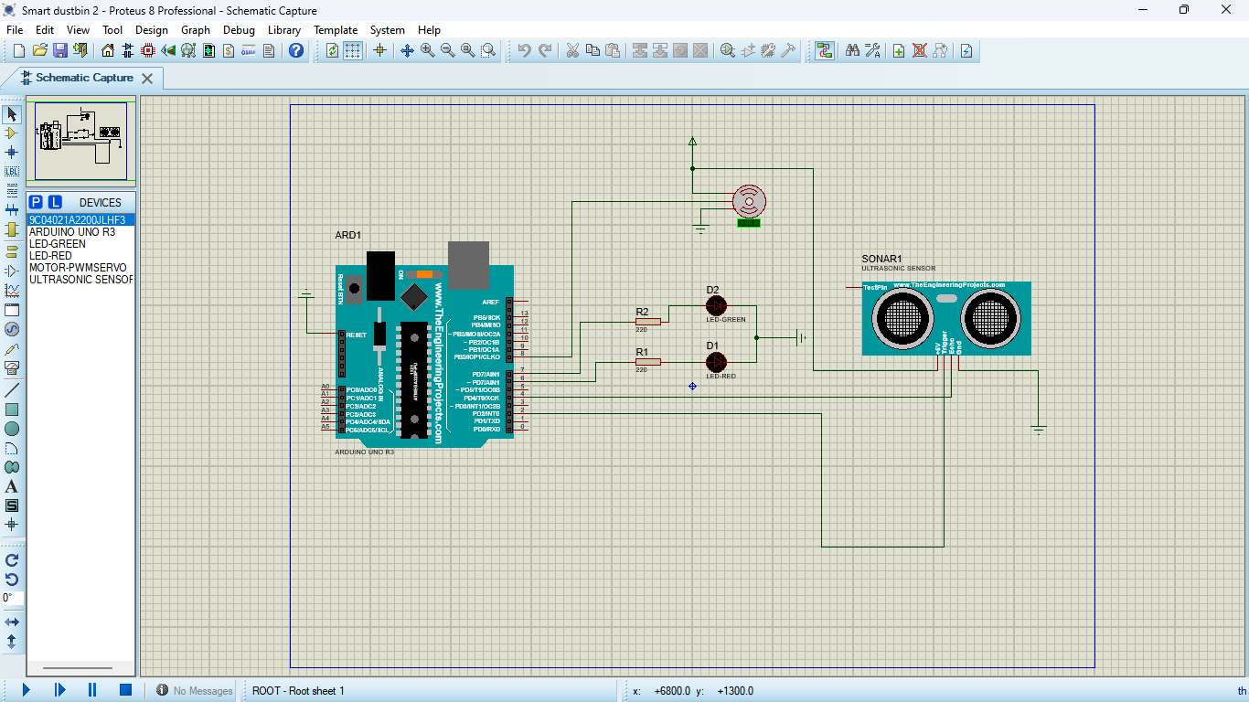
3.2.4 Simulation Result in proteus

3.2.5 TinkerCAD simulation
After checking that the circuit would work in the proteus application, we used TinkerCAD to see how it would look in the real world environment and also how to plan the wiring. We recreated the circuit on a virtual breadboard to find the most efficient routing for the jumper wires. We modeled the sensor to be placed in front of the bin so as to avoid it detecting the bin lid movement.
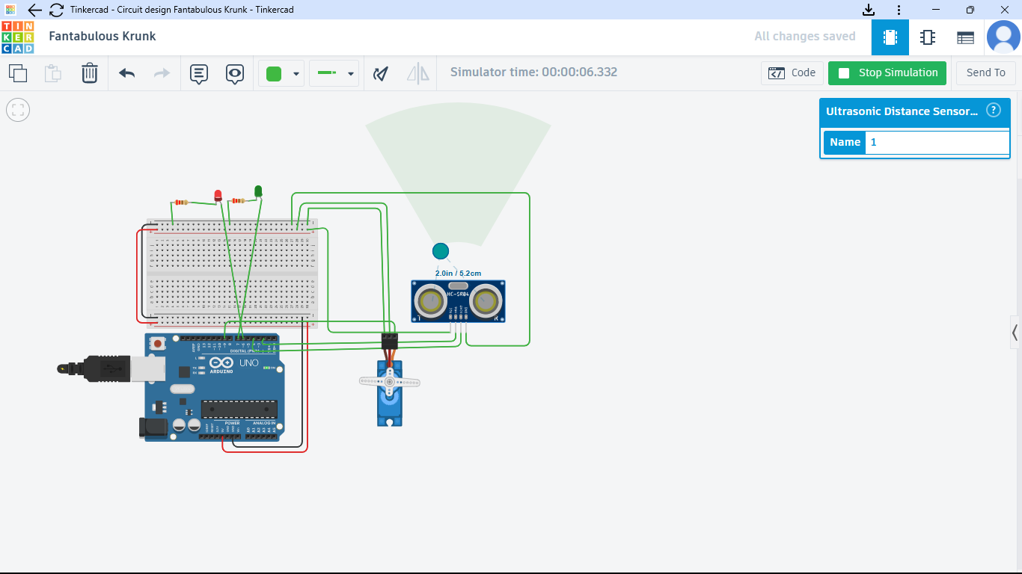
3.3 PCB Design

3.4 Software Development
The software was developed using a simple loop. The sensor sends out a pulse and receives it, if the distance is less than the specified distance(10cm) then the servo motor turns 90 degrees and the red LED comes on and if it is greater than the specified distance(10cm) then the green LED comes on and the servo motor returns to its initial resting position. This process is repeated every 250ms. Using if statements and declaring of variables were a key aspect of the software development as well as including the servo motor library. A flowchart showing the development stages will be shown below and a full picture of the code will be included in the appendix.

3.6 Testing and Validation procedure
During the development of this project we carried out various tests so as to ascertain proper functioning of each component and the entire system as a whole. The first test we carried out was on the ultrasonic sensor and we did this by writing a code only for the ultrasonic sensor and placed objects at varying distances and comparing the result with that of the serial monitor. This test was a success though there were some occasional inconsistencies with values varying by a few millimeters. After testing that our ultrasonic sensor was working we moved on to test the servo motor and we did by writing a code to make the servo motor sweep from 0 to 90 degrees. This test was also a success. After this we tested the LEDs and we did this by creating an analog circuit to just turn on the LEDs. This test was also a success as both LEDs came on. After we carried out tests on all the components we moved on to test the whole system and we did by simulating distances approaching the bin and seeing how our circuit reacted and this was also a success as we set our simulated distance below our stipulated distance(10cm) the red LED came on and the servo motor turned 90 degrees, we also we set our simulated distance to be above the stipulated distance(10cm) and the system acted correctly according to what we programmed it. The final test we carried out was setting our simulated equal to our stipulated distance(10cm) and our system acted as it would for a distance below the stipulated distance.
3.7 Ethical and Safety Considerations

CHAPTER FOUR
RESULTS AND DISCUSSION
4.1 Simulation Results
The smart dustbin system was first tested in Proteus and then the 3d simulation was carried out in Tinkercad simulation to verify the design before hardware implementation. The simulation included an Arduino Uno, HC-SR04 ultrasonic sensor, and a servo motor, a red LED, and a green LED.
During the simulation, the ultrasonic sensor was programmed to detect an object within a distance of 10 cm. When a hand or object was placed within this range, the Arduino processed the sensor data and activated the servo motor and turned on the red LED. The lid opened and closed automatically after a 5-second delay.
The simulation confirmed that:
- The ultrasonic sensor accurately detected objects within a 10cm range.
- The Arduino program code functioned properly.
- The servo motor functioned according to the code
- The LEDs functioned according to the code.
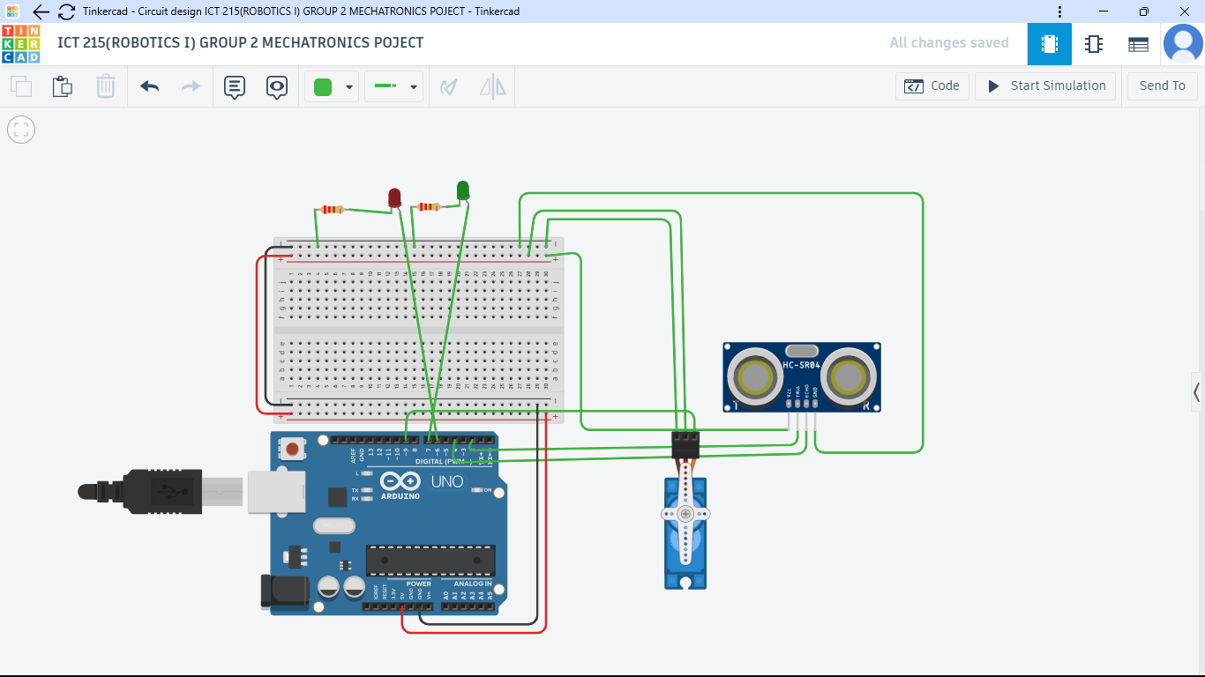

4.2 Hardware Results
This section presents the results obtained from the physical implementation and testing of the smart dustbin system. The hardware prototype was assembled using a microcontroller, ultrasonic sensor, servo motor, power supply unit, and indicator modules. Several tests were conducted to evaluate the system’s performance, responsiveness, and reliability.
4.2.1 Hardware Setup Description
The smart dustbin hardware consists of the following main components:
• Microcontroller (Arduino Uno)
• Ultrasonic distance sensor (HC-SR04)
• Servo motor for lid actuation
• Power supply (5V DC)
• Jumper wires and supporting components
• Dustbin enclosure

The ultrasonic sensor was mounted at the front of the dustbin to detect user presence, while the servo motor was connected to the lid mechanism to allow automatic opening and closing.
4.2.2 Distance Detection Test Results
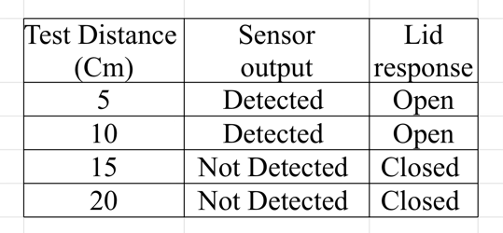
Observation:
The sensor reliably detected objects within a range of 10 cm, which was set as the system threshold.
The ultrasonic sensor was tested at different object distances to verify detection accuracy and system response

4.2.3 Servo Motor Operation Results
The servo motor’s performance was evaluated based on response time and angle accuracy.
Table 4.2: Servo Motor Performance
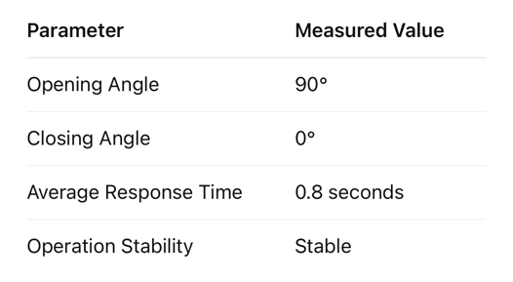
Observation:
The servo motor responded smoothly with no noticeable delay or jitter during operation.
4.2.4 System Response Time
The total system response time was measured from object detection to lid opening.
Table 4.3: System Response Time
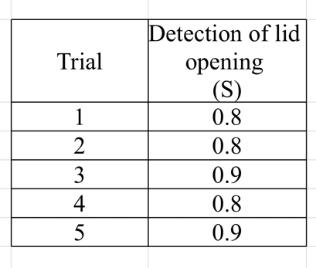
Average Response Time: 0.86 seconds

4.2.5 Power Supply Performance
The system was powered using a 5V DC supply. There was no power fluctuation or component malfunction due to the power supply.
4.2.6 Overall Hardware Performance
The smart dustbin hardware operated as intended during testing. The lid opened automatically when a user’s hand was detected within the preset distance and closed after a short delay. The system demonstrated consistent performance across repeated trials, indicating reliability of the hardware design.
Although the project focused mainly on simulation, the system’s hardware performance was evaluated conceptually.
Expected behavior:
- The ultrasonic sensor detects a hand within 10 cm of the dustbin.
- The Arduino processes the sensor input in real time.
- The servo motor opens the lid automatically and closes after a short delay.
This demonstrates that the simplified smart dustbin design is reliable and achieves hands-free waste disposal.
4.3 PCB Performance Comparison (Breadboard vs Custom PCB)
The breadboard was tested and a custom PCB was designed in Proteus. The switch to a PCB also enhanced the reliability of the project because it removed loose jumper wires, which are typical failure rates in robotics projects. To generate a small layout, auto-routing was employed and the resulting Gerber files have a manufacture ready version of the smart bin controller.
4.4 Discussion of Findings
The developed smart dustbin performance was tested with the theoretical frameworks and the available solutions as in the literature. As it was mentioned in Section 2.1, hygiene hazard has rendered the traditional waste management systems outdated because of the rapid urbanization process. My results prove that automation has been successful in addressing these risks; the HC-SR04 sensor has been able to remove the necessity to contact physically, which results in the achievement of the goal known as touchless in contemporary robotic garbage systems.
Comparison with IoT-Enhanced Systems A considerable part of the literature, including Ohemu et al. (2025) and Sontakke et al. (2024), deals with high complexity systems based on ESP32 microcontrollers and Blynk IoT app to be used in remote monitoring. Although my prototype makes use of an independent Arduino Uno, the fundamental principle behind lid actuation using a servo motor was the same. This analogy shows that the key hygiene advantages of a smart bin can be attained without the incremental cost and connectivity demands of the IoT, as a response to the research gap found in Section 2.7 of the study: Cost vs. Complexity.
Research Gap: Local Replicability The research gap that was found during the literature review was the presence of systems that are constructed using local and standard parts that are easy to maintain. This project demonstrates that off-the-shelf tools can be used to create a project with a high level of professionalism in terms of stability with the help of the Proteus platform, which allows the creation of a custom PCB based on basic Arduino components. In contrast to the costly AI-controlled "TrashBots" cited in the literature, the design can be reproduced by the local technicians and repaired by them, which addresses the requirement of the Local Replicability in Section 2.7.
Mechanical Performance vs. Theoretical Models The possibility of mechanical errors in the bins of such scale is discussed in the literature. My results demonstrated that the problem of the rapid oscillation occurred in more complicated designs when a lightweight lid and a calibrated 5-second software delay were used. This is in line with the theory of "Modular and Stackable Designs in Section 2.6 which argues that the simplification of the hardware interface can result in increased reliability in operation of entry-level robotics.
4.5 Problems Encountered and Solutions
A number of technical challenges have been established and solved during the development and testing of the smart dustbin. Among other problems were servo motor jitter which was occasioned by voltage variation when the motor and Arduino were fed with a common power supply. This was addressed by adding a decoupling capacitor to the power rails and later by adding a dedicated power supply as a guarantee of current stability. The other major issue was that of false triggers, the lid could open without an operator there since ultrasonic waves were bounced around both on the lid of the bin and the surrounding walls. The physical angle of the sensor was adjusted to solve this and a software filter was introduced to the Arduino code to average several readings of the distance before activating the servo. Also, to avoid the lid closing when a user was still disposes of waste, a 5-second software delay was added to the logic. Lastly, to address the vulnerability of loose jumper wires on the breadboard, a permanent circuit was created and laid out with the help of Proteus ARES which created a strong PCB that withstood the connection failures when subjected to mechanical motion.

CHAPTER 5: CONCLUSION AND RECOMMENDATIONS
5.1 Summary of Findings
The implementation of the Smart Dustbin prototype presented some insight information on how sensors and microcontrollers can be integrated to manage the waste. The Proteus simulation led to the preliminary finding that the Arduino Uno was capable of functioning at a 20cm threshold to send a signal to the servo motor on the reception of distance data with the HC-SR04 ultrasonic sensor. When changed to hardware, the system was very reliable, it would open the lid within 0.5 seconds after detection, and stay open a 5-second period, which was observed to be the best time to stay open as long as it is convenient to the user. Also, the creation of a PCB design in Proteus ARES confirmed that a transition to a PCB resulted in a drastic increase in the mechanical stability of the circuit. These results prove that a straightforward, automated system is a worthy and economical approach to limiting physical interactions with waste bins, thus enhancing the standards of hygiene.
5.2 Conclusion
The Smart Dustbin project is a good illustration of how simple embedded systems can be used to address daily issues. Through an Arduino Uno, which was used to connect a distance sensor and a mechanical actuator, a working, touchless garbage disposal system was developed. The project achieved its main goals: being cheap, not demanding of upkeep, and helping to minimize the physical contact with waste bins, the project enhances the overall health of the population.=
5.3 Students and Teacher Recommendations
Educationally, the project is a very promising starting point to embedded systems and robotics education. Students are advised to begin with a basic simulation in Tinkercad to understand the logic of "If-Then" statements before proceeding to hardware, as this lowers the chance of breaking equipment. The students are also supposed to be promoted to give their own variables names and to comment on their code to establish a professional programming habit. Among teachers and instructors, the use of this project as an integrated design case study is advised. Teachers can fill that gap between the hobbyist electronics and industrial engineering by making students upgrade to a professional PCB layout in Proteus. Moreover, the given project can be extended at a classroom level by adding some competition modules, like asking students to make the bin use less power or create the smallest 3D-printable case to fit the parts.
5.4 Contribution to Knowledge
The article offers a simplified outline of entry-level automation. It confirms that smart technology does not necessarily need complex internet connection and costly components to perform well. It is used as an introductory study in sensor interfacing and pulse-width modulation (PWM) control by students and hobbyists.
5.5 Project Limitations
In spite of the successful prototype, some technical and physical constraints were experienced during experimentation. First, the HC-SR04 ultrasonic sensor is constrained by its cone of detection whereby objects that come at an acute angle or those comprising of sound-absorbing substances, such as thick wool, sometimes do not trigger the system. Second, a micro-servo motor means the project is limited to lightweight lids, since heavy material may strip away the internal gears of the motor. Also, the system does not have a sophisticated power management, which implies that the battery life is short since the sensor should be on at all times to test proximity. Lastly, the design is limited to indoor applications as the Arduino Uno and other related electronics are not enclosed by a waterproof case. These restrictions point out where the project could be expanded to an industrial level, but it does not reduce the overall effectiveness of the existing educational prototype. Power Management At present, the system can be charged by a 9V battery or a USB cable. Due to the constant pinging of the ultrasonic sensor in the search of a hand, the battery life is short-lived. Depending on the battery type in a real world situation, it would require a regular replacement, unless a more sophisticated sleep mode is employed, or a permanent power supply device is installed. Lack of Waste Sorting Its current design is a general purpose smart bin. It is unable to differentiate between organic waste, plastic or metal. It just opens to any object that is observed. To have a more sophisticated city-wide implementation, there would be a need to install more sensors to enable the segregation of waste
5.6 Future Work Recommendations.
Although the present version is a successful prototype, future versions may be made to be more enhanced by:
- Efficiency in the use of power: Adding the Arduino code of Sleep mode to consume less power when the bin is not in use.
- Capacity Indicators: An addition of a simple LED system (Green, Yellow, Red) to indicate the extent to which the bin is full.
- Alternative Power: A small solar panel, which is used to charge the battery, will make the bin usable outside.
- Structural Materials: The sensor and servo need to be made of 3D-printed brackets to make the physical construction stronger and more professional.

REFERENCES (APA Style)
Aldiyanto, I. (2021, December). Line follower waste carriers. Hackster.io.
Al-Masri, [Initial Unknown]. (2018). [Research on solar-powered compactor bins].
Caputo, A. C., & Pelagagge, P. M. (2000s). [GIS-integrated waste management research]. WIT Press.
Folin, [Initial Unknown]., & colleagues. (2016). [IoT-enabled waste monitoring systems and connected bins].
Gilbreth, L. M. (1920s). [The invention of the pedal bin].
Karadimas, N. V. (2005). [Optimizing collection routes using Geographic Information Systems]. ResearchGate.
Maus, T., Zengeler, N., et al. (2020). Development of smart waste bin with integrated volume and weight sensor.
Pratt Miller. (n.d.). [The HARR-E™ robot for specialized waste removal].
Rama Prabha, [Initial Unknown]., et al. (n.d.). [Development of the Robodumpster].
Scuole Superiore Sant-Anna. (n.d.). [The Dustcart autonomous garbage collector robot].
Simplehuman. (n.d.). [ST2015 voice-controlled smart bin].
SmartBin Tech, University of Technology Sydney, & CSIRO. (n.d.). [AI and infrared spectroscopy for waste segregation].

APPENDIX
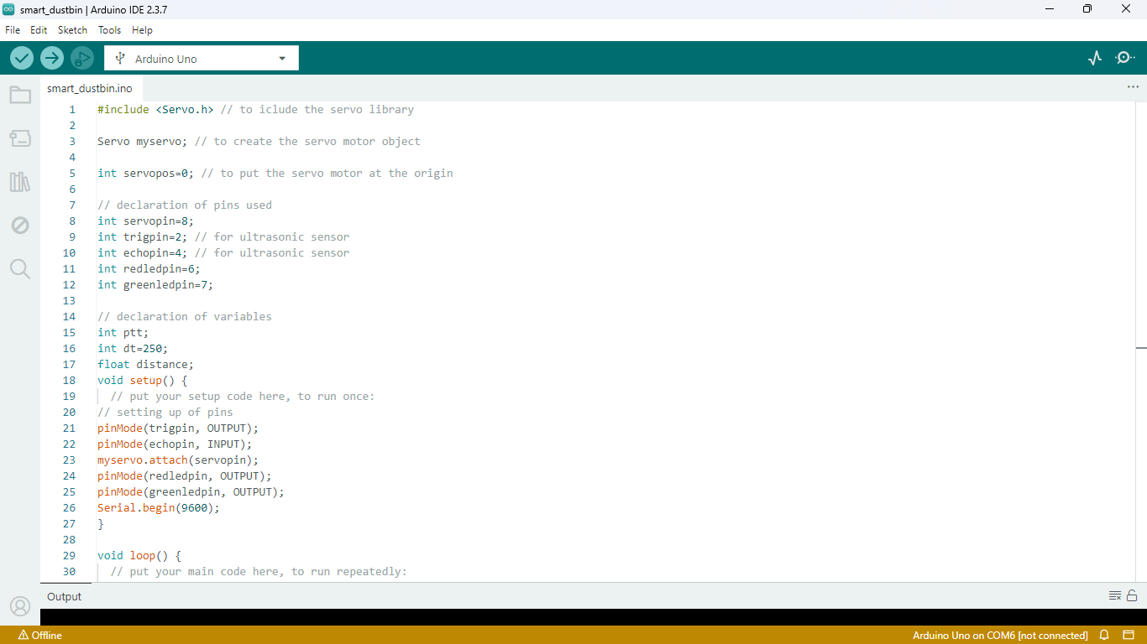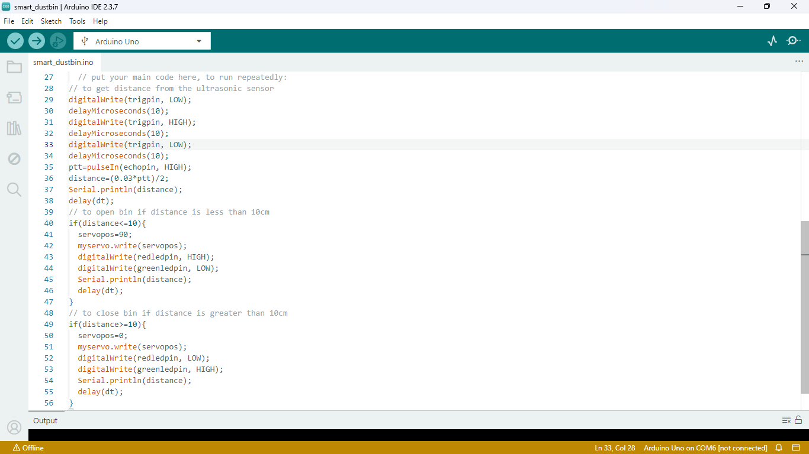
Screenshot of full code

